Repository creation on GitHub

Manish Basnet

2026 Summer - Artificial Intelligence for Human-Computer Interaction (MSAI-631-M90)

Dr. Dennis

May 2026

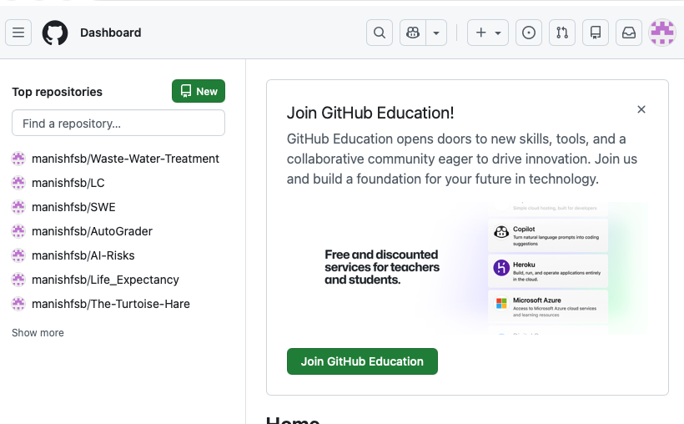
Step 1: Logging In
I already had a GitHub account, so I just logged in. manishfsb is my username, as shown in the top repositories list.

Step 2: Create a new private repository
I have named the repo ‘AI4HCI’ and added a brief description. I forgot to add the README and .gitignore in this step, but I set them up later.
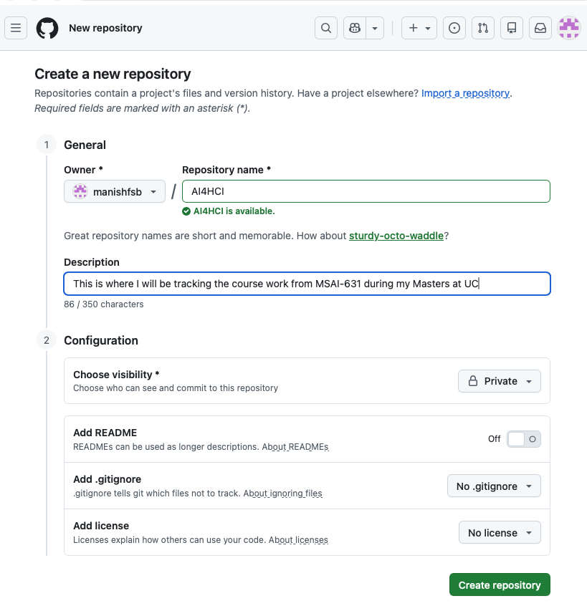
Step 3: Add the instructor as a Collaborator
I then added Dr. Dennis as a collaborator on the repo.
